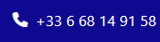
1) Phone Format : +33 – 06 68 14 91 58 (Requested to be Click to dial)



2) Change Font color to Orange like this :

3) Font : BOLD - and Why us ? (Question mark)

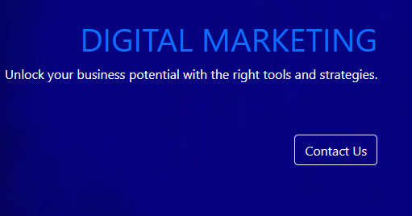
4) Replace CTA Contact us

By this :
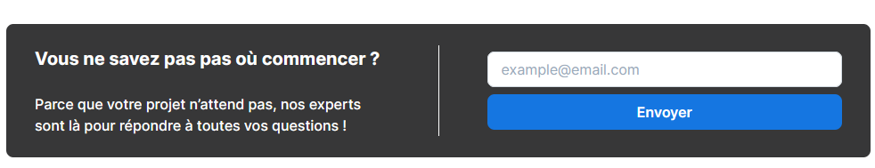


This is actually VERY NICE ! :)))

Minor changes : - All in cap font or all in minor font, not mixed please
- Webdesign in second position please
- Font Color Dark blue
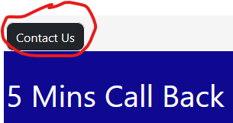

5) Remove CTA Contact us upside

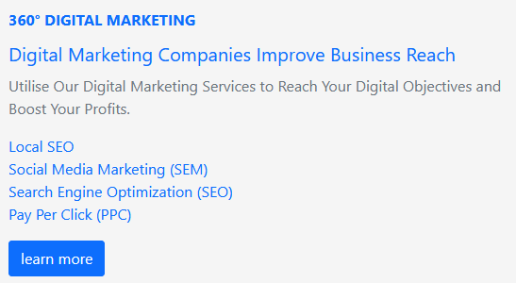
6) Font color difference : Before Dark blue, now Light Blue… WHY?

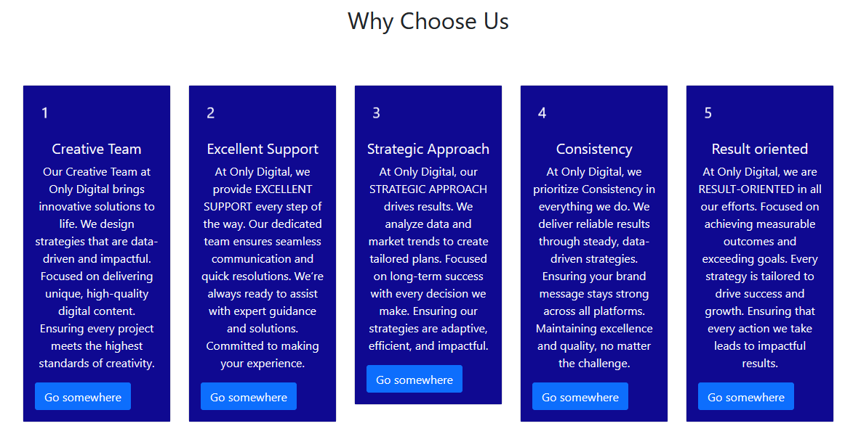
7) Replace this

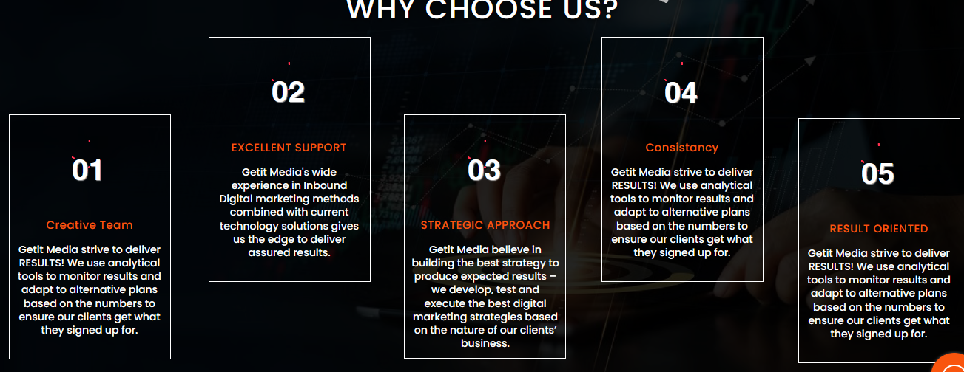

By this (Zigzag, Dynamics & color changes)
Also very good work ! :)



8) Please ADD also this Text part (next to or below the existing video)

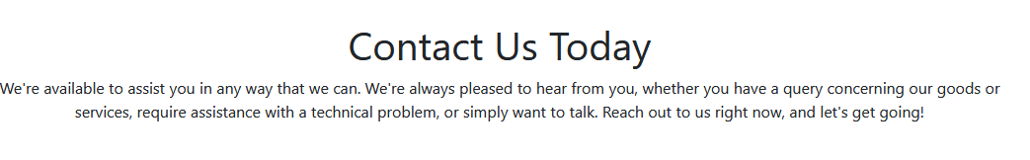
9) CTA Missing

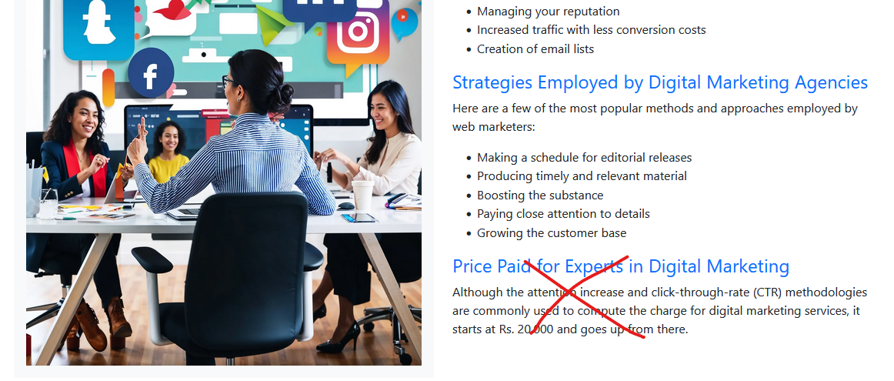
10) Image looks over stretched… Please verify

Remove last paragraph (we have No Minimum for the Beginning ;)

Again Font color different ?

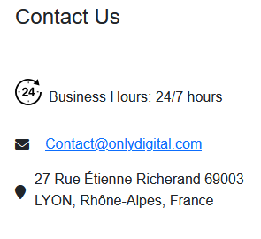

9) Remove this please (Personal Adress)

10) Please remove all images with English terms (FRENCH WEBSITE!)

Question : What about Consent cookies ?
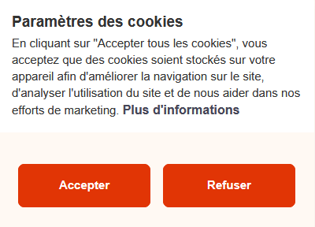

Appointment Reservation example :
1) Go to this website : https://1kubator.com/
2) Click here :
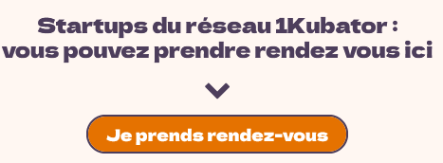

3) New page to Reserve a Free Appointment with Calendar & Time Slots
